**Grade 5 Animal Systems Summative Exam**

**Multiple Choice**

*Identify the choice that best completes the statement or answers the question.*

____ 1. Tony always drinks water before and after his long bike rides. Why does his body need water when he exercises?

|  |  |
| --- | --- |
| a. | Drinking water after exercise allows the body to sleep. |
| b. | Drinking water after exercise helps to replace lost fluids. |
| c. | Drinking water before exercise helps increase the heart rate. |
| d. | Drinking water before exercise prevents the body from sweating. |



____ 2. The picture above shows some of the organs that can be found inside the human body. What is the main job of the organ labeled 1?

|  |  |
| --- | --- |
| a. | carrying air |
| b. | carrying food |
| c. | carrying blood |
| d. | carrying messages from the brain |

____ 3. Which two systems work most directly with the skeletal system to cause a finger to move?

|  |  |
| --- | --- |
| a. | Nervous and muscular |
| b. | Digestive and excretory |
| c. | Immune and reproductive |
| d. | Circulatory and respiratory |

____ 4. Which of the following systems work together to bring oxygen to a muscle?

|  |  |
| --- | --- |
| a. | Immune and excretory |
| b. | Circulatory and respiratory |
| c. | Nervous and muscular |
| d. | Digestive and integumentary |

____ 5. A scientist wants to find out if physical fitness affects a person’s resting heart rate. Which of the following would be the best group to investigate?

|  |  |
| --- | --- |
| a. | Members of a gym |
| b. | Professional athletes |
| c. | People selected at random |
| d. | Adults who are not overweight |

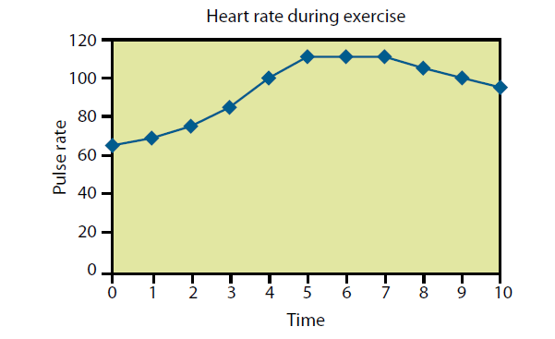

____ 6. A friend measured and recorded his pulse rate while jogging. At what point **on the graph above** do you think he may have stopped running?

|  |  |
| --- | --- |
| a. | 2 minutes |
| b. | 4minutes |
| c. | 6 minutes |
| d. | 8 minutes |

____ 7. The kidney is responsible for filtering waste material from blood. It is part of what body system?

|  |  |
| --- | --- |
| a. | Excretory |
| b. | Digestive |
| c. | Circulatory |
| d. | Reproductive |

Use the following charts to answer the next question.

|  |  |
| --- | --- |
| Age: | Target Heart Rate Range: |
| 20 | 120-170 |
| 25 | 117-166 |
| 30 | 114-162 |
| 35 | 111-157 |
| 40 | 108-153 |
| 45 | 105-149 |
| 50 | 102-145 |

|  |  |
| --- | --- |
| Physical Activity: | Sample Heart Rate after 10 Minutes |
| Cleaning house | 95 |
| Downhill skiing | 115 |
| Jumping rope | 140 |
| Walking | 108 |

____ 8. When people exercise regularly and keep their heart rate in the target range, their heart gets healthier. Based on the information above, what is the best exercise for a 25 year old that wants to improve her heart?

|  |  |
| --- | --- |
| a. | Cleaning house |
| b. | Downhill skiing |
| c. | Jumping rope |
| d. | Walking |

____ 9. What is the primary purpose of the digestive system?

|  |  |
| --- | --- |
| a. | Eliminate hunger |
| b. | Transport food to cells |
| c. | Remove waste products |
| d. | Break down energy sources |

____ 10. Which of the following helps muscles support the body?

|  |  |
| --- | --- |
| a. | nervous system |
| b. | skeletal system |
| c. | respiratory system |
| d. | reproductive system |

____ 11. What do the respiratory and excretory systems have in common?

|  |  |
| --- | --- |
| a. | They have the same major organs. |
| b. | They supply raw materials for growth. |
| c. | They only function when a person is awake. |
| d. | They eliminate waste materials from the blood. |

____ 12. A friend wants to find out how running in place affects breathing rate. Which of the following tools will he need to use?

|  |  |
| --- | --- |
| a. | scale |
| b. | stop watch |
| c. | meter stick |
| d. | thermometer |

____ 13. Which graph best shows pulse and breathing rates for a person who starts from rest and does two minutes of heavy exercise?

|  |  |  |  |
| --- | --- | --- | --- |
| a. |  | c. |  |
| b. |  | d. |  |

____ 14. During a physical examination, the doctor sometimes hits the patient’s knee with a small hammer to see how his leg will react. What body system is being tested?

|  |  |
| --- | --- |
| a. | Nervous |
| b. | Skeletal |
| c. | Muscular |
| d. | Circulatory |

____ 15. Some people believe it is dangerous to go swimming right after eating a heavy meal. Why might this be a problem?

|  |  |
| --- | --- |
| a. | The muscular system might be too relaxed. |
| b. | The respiratory system might need more rest. |
| c. | The excretory system might need more time to work. |
| d. | The circulatory system might not be able to meet demands. |

____ 16. One way to avoid having back pain is to do sit-ups regularly. This is an example of which two systems working together?

|  |  |
| --- | --- |
| a. | Skeletal and muscular |
| b. | Nervous and muscular |
| c. | Circulatory and skeletal |
| d. | Nervous and circulatory |

**Essay**

17. The heart depends on other body systems. Explain how each of the following is needed to keep the heart pumping and healthy.

a. Circulatory

b. Digestive

c. Excretory

d. Respiratory

18. Describe how the digestive system works in humans. Include at least three steps in the process.